Inception Phase

Online Quote System

Provided to: El Sol Construction

Provided by: Andrea Soto

*Table of Contents*

1 Vision 3

2 Glossary 3

3 Software Requirements Specification 3

3.1 Use Case Specification 3

4 Software Development Plan 5

4.3 Risk List 5

4.4 Requirement Ranking List 5

4.5 Iteration Plan 6

5 Software Architecture 6

6 Milestones 7

6.6 Milestones and Target Dates (Estimate) 7

7 Estimated Costs 8

7.1 One Time Project Implementation Cost 8

7.2 On Going Monthly Maintenance Fees 8

# Vision

El Sol construction is looking to automate the quote system of their website by using today’s latest technology as well as booking follow-up meetings with the prospective clients.

The Online Quote System is intended to enhance the quality of service through transparent and prompt estimation of service costs to customers.

# Stakeholders

|  |  |
| --- | --- |
| **Name** | **Role** |
| Edgar Zepeda | Owner |
| Karysa Lorette | Administrator |

# Proposed Solution

Implement an option to request online quote and incorporate a follow-up meeting request with the vendor.

# Feature List

* Book an appointment
* View calendar on iCalendar via subscription
* Generate Quote
* Approval system
* Administrator Dashboard

# Domain Model

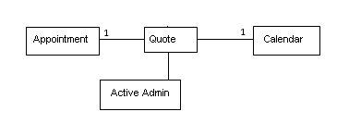

# Actor-Goal List

|  |  |
| --- | --- |
| **Actor** | **Goal/ Description** |
| Customer | Perspective client that goes to the El Sol Website |
| Administrator/Vendor | El Sol Construction Administrator that will manage quotes and meetings. |

# Use Case Model

|  |  |
| --- | --- |
| Use Case #1: Book Appointment | |
| Pre-Condition(s) | A Quote Code should exist |
| Trigger(s) | None |
| Primary Actor | Customer |
| Brief Description | This use case allows the customer to book a follow-up meeting with the Vendor. |
| Primary Scenario | John Smith enters Quote Code and sees available meeting times. Send a meeting request to El Sol Construction Admin via email and waits for approval. |
| Success Scenario | Customer’s meeting request gets approved. |
| Post-Condition(s) | Form submitted to Website Administrator via email |

|  |  |
| --- | --- |
| Use Case #1.1: Approve meeting request | |
| Pre-Condition(s) | A Quote Code should exist |
| Trigger(s) | None |
| Primary Actor | Administrator |
| Brief Description | This use case allows the Administrator to accept or reject the meeting request. |
| Primary Scenario | El Sol Construction Admin gets meeting request via email and follow the link to reject or accept meeting. |
| Success Scenario | Administrator accepts meeting and the system notifies client. |
| Post-Condition(s) | System notifies client via email |

|  |  |
| --- | --- |
| Use Case #1.3: Add meeting to Calendar | |
| Pre-Condition(s) | Administrator has subscribed to the OQS’s calendar |
| Trigger(s) | Approval of meeting |
| Primary Actor | Administrator |
| Brief Description | This use case allows adding meetings and seeing the appointments on iCalendar. |
| Primary Scenario | Administrator accepts meeting request and is able to see events on iCalendar. |
| Success Scenario | See new meeting on iCalendar |
| Post-Condition(s) |  |

|  |  |
| --- | --- |
| Use Case #2: Generate Quote | |
| Pre-Condition(s) | None |
| Trigger(s) | None |
| Primary Actor | Customer |
| Brief Description | This use case allows the customer to request a quote. |
| Primary Scenario | John Smith enters required information and submit Quote request. |
| Success Scenario | Customer submits request |
| Post-Condition(s) |  |

|  |  |
| --- | --- |
| Use Case #2.1: Approve Quote | |
| Pre-Condition(s) | Quote request submitted |
| Trigger(s) | None |
| Primary Actor | Administrator |
| Brief Description | This use case allows the Administrator to review and accept generated quote. |
| Primary Scenario | Administrator receives email with quote request information |
| Success Scenario | Administrator approves quote. |
| Post-Condition(s) | Customer received approval and Quote Code |

# Narrative

* 1. Use Case for Book Appointment

Description: This use case allows the customer to book a follow-up meeting with the Vendor.

Primary Scenario: John Smith enters Quote Code and sees available meeting times. Send a meeting request to El Sol Construction Admin via email and waits for approval.

John Smith, a member of general public, sees available meeting times but he needs to enter an existing Quote Code in order to submit the request. After picking the time slot, the address information is required in order to proceed with request.

The system checks which time slots are available and verifies if Quote Code exists in order to allow request. After confirmation, system sends request via email to Vendor. A message “meeting successfully requested” will be posted back to John.

Pre-Condition: A Quote Code should exist

Post-Condition: Form submitted to Website Administrator via email

* + 1. System Sequence Diagram

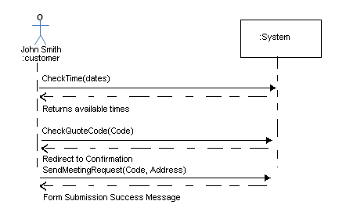

* 1. Use Case for Approve meeting request

Description: This use case allows the Administrator to accept or reject the meeting request.

Primary Scenario: El Sol Construction Admin gets meeting request via email and follow the link to reject or accept meeting

Pre-Condition: A Quote Code should exist

Post-Condition: System notifies client via email

* + 1. System Sequence Diagram

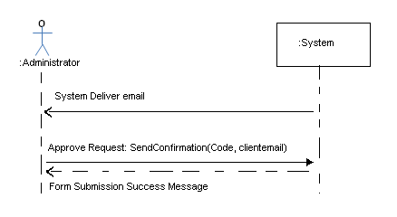

* 1. Use Case for Add meeting to Calendar

Description: This use case allows adding meetings and seeing the appointments on iCalendar.

Primary Scenario: Administrator accepts meeting request and is able to see events on iCalendar.

Pre-Condition: Administrator has subscribed to the OQS’s calendar.

There is no Post-Condition.

* + 1. System Sequence Diagram
  1. Use case for Generate Quote

Description: This use case allows the customer to request a quote.

Primary Scenario: John Smith enters required information and submit Quote request

There is neither Pre-Condition nor Post-Condition.

* + 1. System Sequence Diagram
  1. Use case for Approve Quote

Description: This use case allows the Administrator to review and accept generated quote.

Primary Scenario: Administrator receives email with quote request information

Pre-Condition: Quote request submitted

Post-Condition: Customer received approval and Quote Code

* + 1. System Sequence Diagram
    2. **UML Case Diagram**

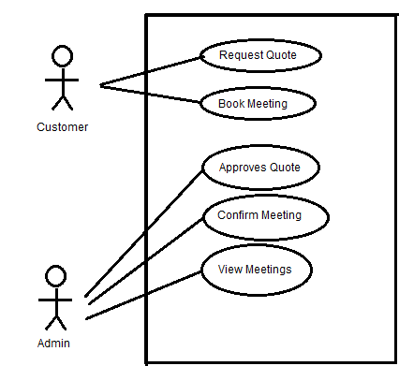

* 1. **Supplementary Specification**

1. System will be available 24/7
2. Meeting request confimation will rely on El Sol Construction Administrator

# Software Development Plan

## Risk List

1. System is unable to resolve customer email address
2. Administrator is unable to contact client due to bad email address
3. Web Server and email server have to be working 24/7

## Requirement Ranking List

|  |  |  |
| --- | --- | --- |
| Use Cases | Hours | Ranking |
| Request Quote | 40 | 4 |
| Book Meeting | 40 | 1 |
| Approves Quote | 25 | 5 |
| Confirm Meeting | 25 | 2 |
| View Meetings | 10 | 3 |

## Iteration Plan

|  |
| --- |
| Tasks |
| Setup: Environment, repository and hosting |
| Design: Database Architecture, front end prototype |
| Development: Booking engine |
| Development: Quoting system |
| Development: business rules |
| Testing: Test functionality |
| Client Testing |

# Software Architecture

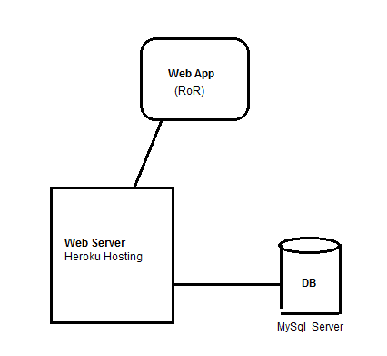

# Milestones

## Milestones and Target Dates (Estimate)

|  |  |  |
| --- | --- | --- |
| **Task** | **Owner** | **Due Date** |
| Preparing Inception Document | Andrea Soto | Jan. 20, 2013 |
| Approval | El Sol Construction | Jan. 25, 2013 |
| Design the OQS application: database & screens | Andrea Soto | Feb 8, 2013 |
| Development: Booking engine | Andrea Soto | Mar. 8, 2013 |
| Development: Quoting system | Andrea Soto | Mar. 26, 2013 |
| Development: business rules | Andrea Soto | Mar. 10, 2013 |
| User Acceptance Testing | El Sol Construction | Apr. 10, 2013 |
| Elevate to Production | Andrea Soto | Apr. 20, 2013 |
| Client sign off and project closure | El Sol Construction | Apr 26, 2013 |

# Estimated Costs

The Fees described in this Estimated Costs section are estimates only.

The labor figures identified below have been calculated using hourly units at $70/hr.

## One Time Project Implementation Cost

The estimated one-time costs for this project are as follows:

|  |  |  |  |
| --- | --- | --- | --- |
| **Deliverable** | **Hours** | **Labour Cost** | **Cost** |
|  |  |  |  |
| Front End Assessment, Document Preparation, Project administration | 10 | $700 | $0 |
| Design, Develop and Implement | 100 | $7000 | $0 |
| Database update in test and production | 30 | $2100 | $0 |
| Meetings and Status reports | 15 | $105 | $0 |
| **Subtotal** |  | **$9905** | **$0** |
|  |  |  |  |
| Contingency (10%) |  | $900 | $0 |
|  |  |  |  |
| **Total Savings** |  | **$10805** | **$0** |

## On Going Monthly Maintenance Fees

|  |  |
| --- | --- |
| **Service Description** | **Monthly Fees** |
| Hosting charges from Heroku | $0 |
| **Monthly Cost for Services** | **$0** |
| **Total Annual Cost for Services** | **$0** |

# Glossary

Customer: prospective client looking for el Sol Construction services

Admin: El Sol Construction Administrator

OQS: Online Quote System